At the Crossroads - Welsh Outdoor Arts Sector Research Report 2025

A research report exploring the future of Articulture and Wales's outdoor arts sector

Prepared by Sequoia

September 2025

Contents
Executive Summary 3
Methodology 5
What We Heard: Current State Assessment 6
External Perception: Respected but Fragile 6
The Funding Crisis 7
The Geography of Inequality 8
What the Sector Needs 11
The Basics: What Artists Need to Survive 11
Articulture's Role: What the Sector Wants 12
Service Priorities 12
Emerging Opportunities and Sector Trends 15
Organisational Transformation Requirements 19
Funding Priorities for Articulture 20
The Earned Income Question 22
What Should Articulture’s Strategic Priorities Be? 23
What Success Would Look Like for the Sector 25
The Counter-Question: If Not Articulture, Who? 27
Conclusion: The Evidence Demands Action 29
Appendices 32

Executive Summary
Between February and September 2025, we consulted over 100 voices across Wales's outdoor arts sector through surveys (89 responses) and stakeholder interviews (17 total). The findings are unambiguous: the sector is in crisis, but there's a clear pathway forward.
The Crisis is Real
- 80.77% identify funding as their primary barrier to work
- 62.9% are concerned about survival over the next five years
- Sector health rated just 3.67 out of 7, barely above the mid-point
- 89.7% identify communities across Wales with no access to outdoor arts
But There's Consensus on the Solution
Stakeholders from every perspective - artists, funders, partner organisations, and Articulture's own directors - agree on what needs to happen:
- Secure core funding (88.9% prioritise ACW partnership as highest priority)
- Build internal capacity through salaried leadership and business development
- Deliver tangible artist support - commissioning (75%), mentoring (86.2%), funding facilitation (60.7%)
- Address geographic inequality particularly in North Wales and rural communities
- Lead sector advocacy once foundations are stable
The Articulture Question
Articulture is universally respected for its sector knowledge, network building, and commitment to quality. 86.2% believe it's best placed to provide artist mentoring and development - the highest response to any survey question. However, the organisation currently operates as a freelance collective, stretched beyond capacity, unable to meet the sector's documented needs.
The Evidence is Clear
Core revenue funding from Arts Council Wales is the necessary first step. Without it, Articulture can't build capacity. Without capacity, it can't diversify funding or scale services. Without sustainable operations, the Welsh outdoor arts sector loses its only dedicated national infrastructure organisation.
The Alternative?
We examined five alternatives: expanding an existing organisation's remit, creating a consortium, the possibility of Outdoor Arts UK opening a Welsh office, having local authorities coordinate, or allowing sector self-organisation. None are viable. Supporting Articulture to transform is more efficient, faster, and more trusted by the community than any alternative.
The Window is Now
Current conditions create both urgency and opportunity. The sector faces crisis but demonstrates strong engagement and clear demand for services. Stakeholders are 65% positive about potential, with unanimous agreement on strategic direction. This combination of need, support, and clarity creates favourable conditions for transformation - if resources can be secured now.
The Welsh outdoor arts sector's future isn't about artistic innovation alone. It's about addressing systemic sustainability through coordinated leadership, strategic resources, and formalised partnerships. Articulture has the mandate. The question is whether it can secure the capacity to fulfill it.

Methodology
Between February and September 2025, we listened to 100 voices from across Wales's outdoor arts sector through a combination of stakeholder interviews and sector surveys. We heard from national organisations and local festivals, established artists and emerging practitioners, audiences and funders, with those who've worked with Articulture for years and those just discovering outdoor arts.
People shared their hopes and their fears, their dreams for what outdoor arts in Wales could become and their anxiety about whether they'll see those dreams realised.
Quantitative Research included:
- Welsh Outdoor Arts Sector Research Survey (n=38)
- Your Voice Matters Survey (n=51)
- Mixed methods: rating scales, ranking exercises, open-ended responses
Qualitative Research included:
- Eleven external stakeholder interviews conducted by Sequoia
- Six Internal interviews with all Directors
- Evidence-led exploration of organisational health, market positioning, and strategic priorities
Stakeholders Interviewed as part of our consultation included:
- Rosie Strang, Small Woods
- Sioned Edwards, National Eisteddfod of Wales
- Laura Drane, the Arts Council of Wales
- Lisa Matthews, the Arts Council of Wales
- Lucy Medleycott, ISACS
- David Doust and Sho Shibata, Outdoor Arts UK
- Louise Miles-Davis, Creu Cymru
- Nicola Edwards, Awen Cultural Trust
- Emma Evans, WMC
- Iwan Glyn Williams, Ffiwsar
- Zoe Munn, Independent Producer & Greenman Festival
Please see Appendix C for further detail on methodology.

What We Heard: Current State Assessment

External Perception: Respected but Fragile
Stakeholder interviews reveal unanimous recognition of Articulture's vital historical role as "the early leader in the development of outdoor arts in Wales." However, this positive perception is qualified by concerns about current organisational capacity and future sustainability.
Strengths Identified:
- Deep sector knowledge and expertise (universally acknowledged)
- Strong networks and partnership facilitation
- Commitment to artistic excellence in commissioning
- Credibility as advocate and promoter nationally and internationally
Critical Vulnerabilities:
- Financial instability: Reliance on "insufficient project-based funding" creating perpetual insecurity
- Capacity constraints: Small team "stretched" and unable to scale operations
- Strategic gaps: "Lack of long-term strategy" and clear leadership limiting sector influence
- Structural disadvantage: Operating within a sector facing "limited government support"
Sentiment Analysis from stakeholder interviews:
- Positive sentiment: 65% (confidence in role, strengths, opportunities)
- Neutral/constructive: 25% (balanced perspectives on challenges)
- Negative sentiment: 10% (concerns about financial instability)
Internal Organisational Reality
Director interviews reveal an organisation aware of its precarity and committed to transformation but lacking capacity to execute change:
Current Operating Model:
- Loose collective structure with paid freelance arrangements
- No salaried team preventing structured outreach and business development
- Reactive rather than proactive engagement with policy and funding bodies
- Absence of dedicated business development or advocacy functions
Critical Gap Identified: All directors acknowledged "lack of internal capacity for business development" while confirming "commitment to making change" – highlighting the central paradox: the organisation needs transformation capacity to survive but lacks resources to build that capacity.

The Funding Crisis
When we asked people about their biggest challenges, 80.77% identified funding as their top concern. Not "a concern" or "one of several challenges" - the primary obstacle preventing them from doing their work.
Four out of five people working in outdoor arts - artists creating performances in village squares, festivals bringing communities together, organisations connecting audiences with extraordinary experiences - are telling us they can't sustain what they're doing.
- 80.77% ranked lack of funding as their #1 concern
- This is figure was even higher in community survey (Your Voice Matters) with 96% placing funding constraints as top challenge
- 62.9% expressed concern or serious concern about five-year sustainability
- Only 3.7% felt confident about the sector’s financial future
External stakeholders identified "financial vulnerability" as Articulture's key operational challenge, noting that insufficient resources make it "difficult for Articulture to grow and support artists effectively."
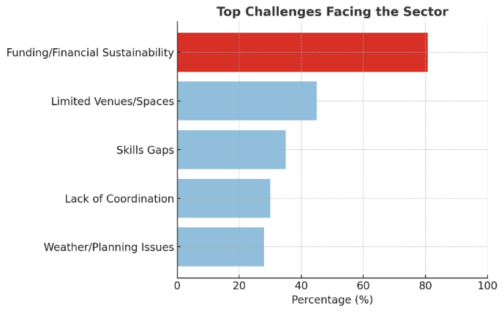
Sector Health Score: When we asked people to rate the overall health of the outdoor arts sector, the survey data corroborates stakeholder concerns, rating sector performance at barely adequate levels across all dimensions (3.27-3.77 on 1-7 scale). This quantitative evidence supports qualitative assessments that the outdoor arts sector in Wales faces "structural difficulties."

The Geography of Inequality
But the crisis isn't evenly distributed across Wales. When we mapped where people are working versus where people want outdoor arts to happen, we found a disconnect.
Survey data revealed striking agreement: 89.7% identified communities or regions currently underserved by outdoor arts. This near-unanimous recognition establishes geographic inequity as the sector's second-defining challenge after funding.

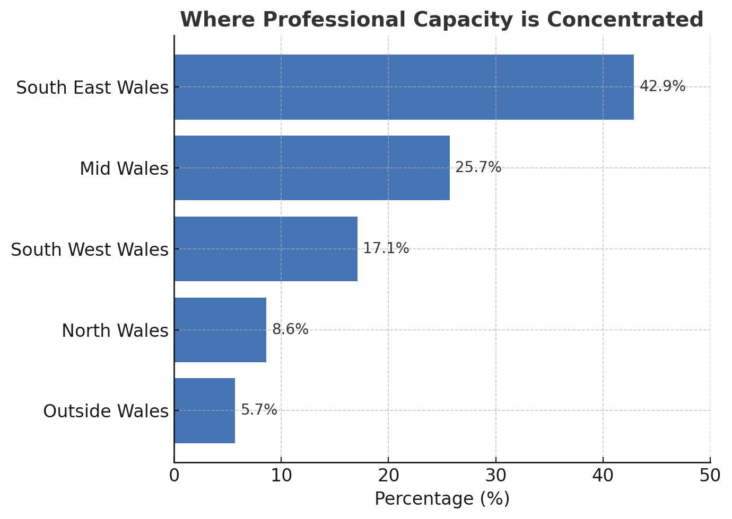
Regional distribution of survey respondents suggests gaps:
- South East Wales: 42.9% (over-represented)
- Mid Wales: 25.7%
- South West Wales: 17.1%
- North Wales: 8.6% (significantly under-represented)
Professional capacity concentrates in Southeast Wales - 42.9% of sector organisations. That makes sense; it's where population, funding bodies, and infrastructure cluster.
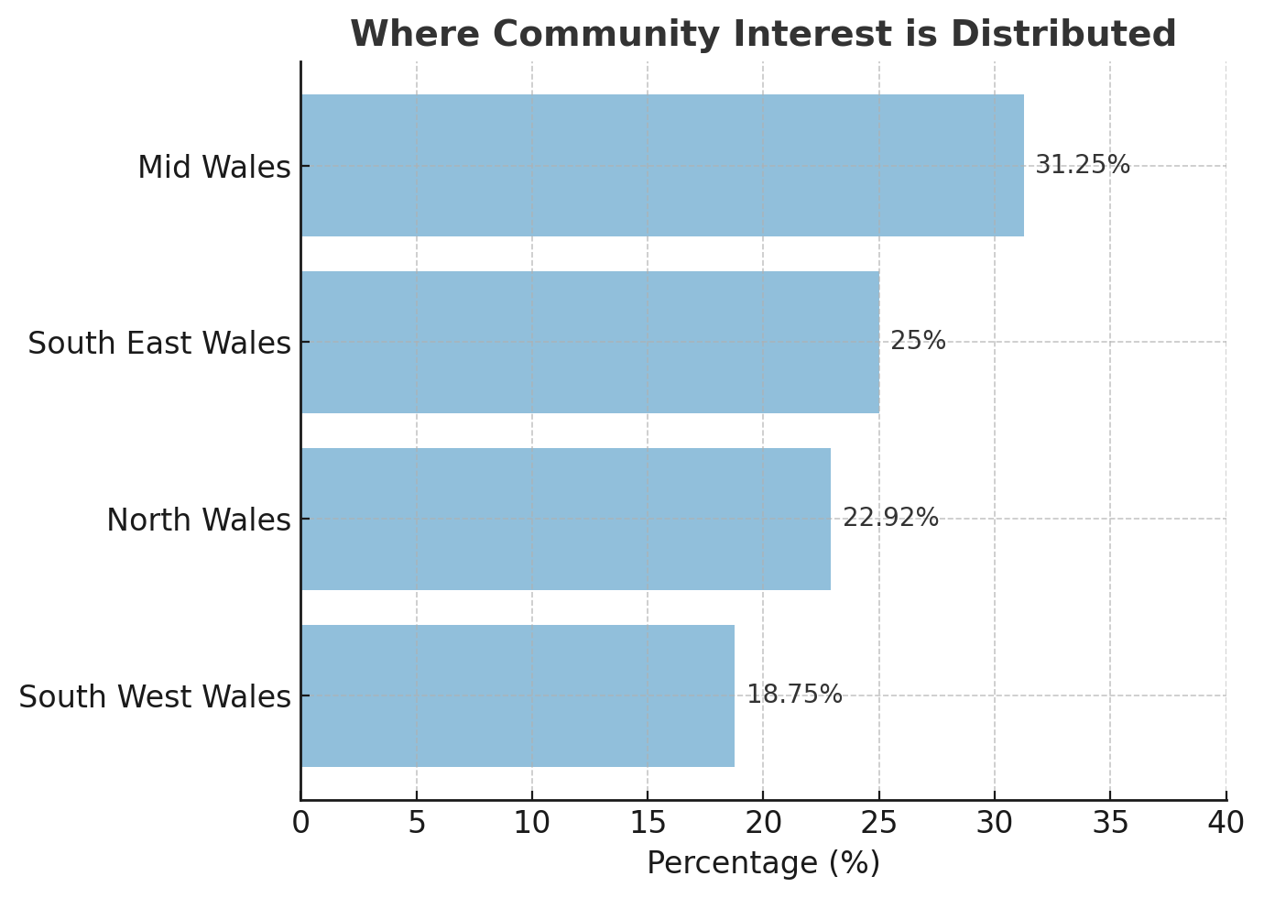
But when we asked where communities lack outdoor arts opportunities, people pointed to North Wales, Southwest Wales, rural Mid Wales. The places where outdoor arts could have the most impact - free, accessible cultural experiences in communities with limited arts infrastructure - are the places least served.
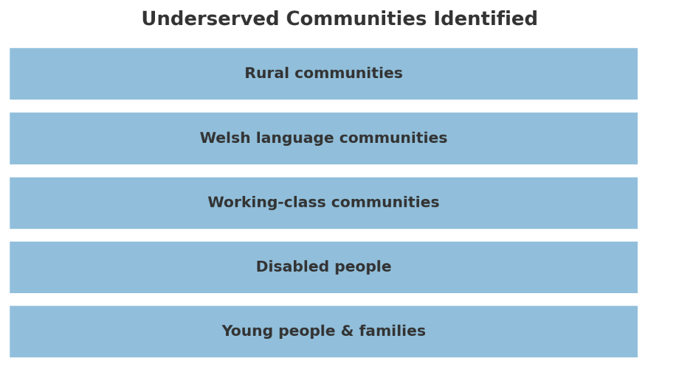
89.7% of respondents identified underserved communities or regions. Nearly nine out of ten people working in outdoor arts believe significant portions of Wales are being left out. These aren't niche audiences, this is the majority of Wales.
Access Barriers
The survey responses identified specific obstacles to geographic equity:
- More funding and grants needed: 93.8%
- Better marketing and promotion: 65.6%
- Free or low-cost events: 59.4%
- Multi-language support: 34.4%
- Simplified permitting processes: 31.3%
These barriers suggest geographic inequity results not from lack of interest but from systemic resource and infrastructure gaps – addressable through strategic intervention.
Stakeholder perspective: External interviews identified "Regional and UK-wide Expansion" as an opportunity, suggesting Articulture could extend impact "by collaborating with partners beyond Wales" – though this must be balanced against core geographic equity within Wales.

What the Sector Needs
Against this backdrop of funding crisis and geographic inequality, we asked people what would actually help. Their answers fell into two categories: immediate survival needs and the role they want Articulture to play.

The Basics: What Artists Need to Survive
When we asked what would help most, people didn't request strategy documents or international showcases. They asked for basics:
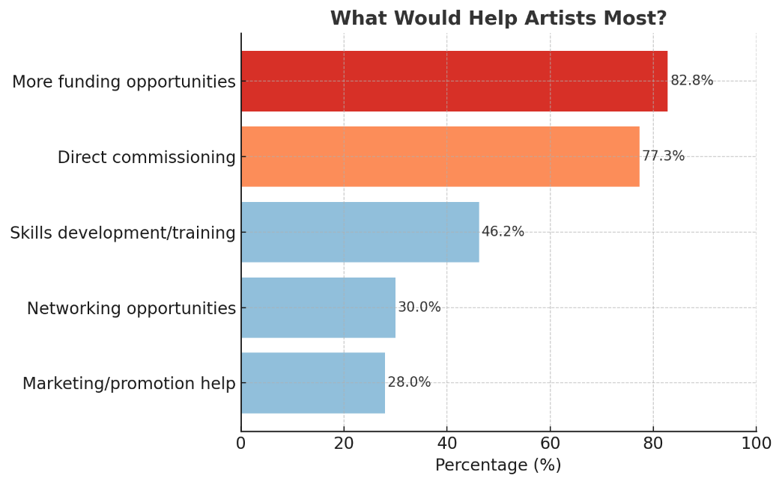
- 82.76% want more funding opportunities
- 77.3% want direct commissioning
- 46.2% want skills development and training
- 30.0% want networking and collaboration
One artist wrote: "Capacity to deliver, the hunger is there but without sustainable funding we can't make the magic happen."
Another: "Limited touring opportunities make building a sustainable tour impossible."
A Local Authority stakeholder wrote: "We are not from an arts background, we don't have funding for this, and would need to be supporting the project, not leading it."
People clearly want paid work opportunities more than anything else, though the strong interest in training (46.2%) shows that artists are keen to develop their skills when it could help their careers. This confirms what we know is true: artists don't have enough funding to actually make their work.

Articulture's Role: What the Sector Wants
54.3% of sector survey respondents have worked directly with Articulture. When people talked about Articulture's strengths, three themes emerged consistently:
- Deep sector knowledge - People value that Articulture understands outdoor arts, knows the practitioners, comprehends the unique challenges.
- Network building - Articulture connects artists with opportunities, organisations with each other, the sector with funders.
- Commitment to quality - Articulture's track record of commissioning and supporting excellent work earns consistent respect.
What is clear is that people know Articulture, trust Articulture, want Articulture to succeed.

Service Priorities
When we asked what Articulture should focus on, the responses were unambiguous:
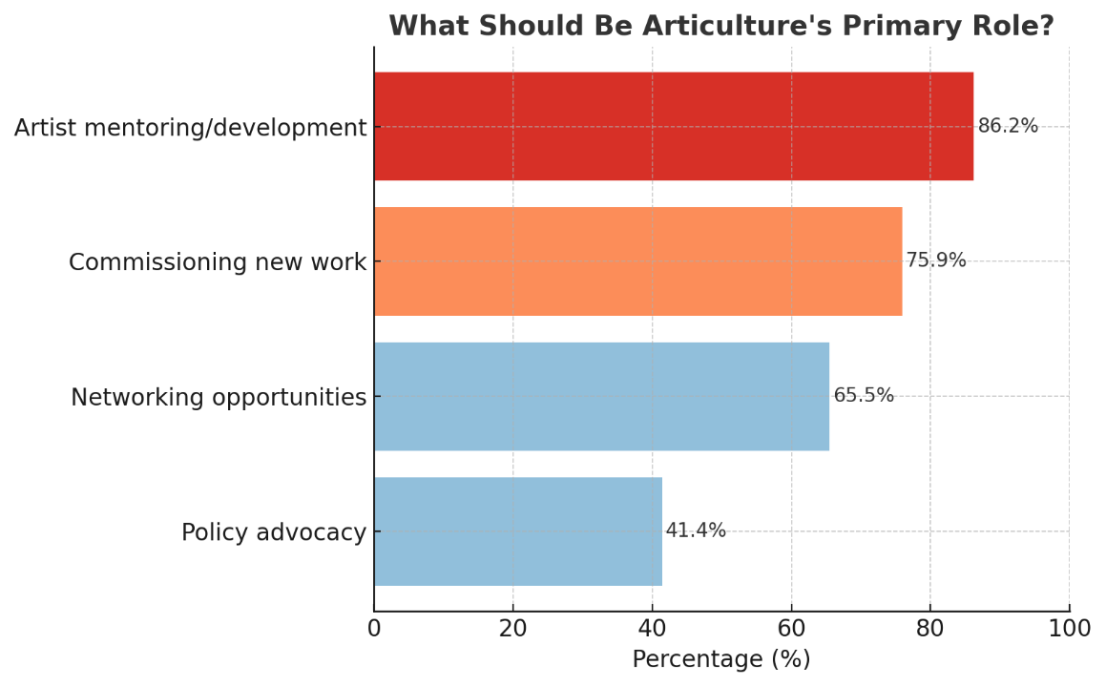
Articulture's unique role:
- 86.2% identified artist mentoring and development - the highest single response to any question in the survey
Top priorities for Articulture:
- Commissioning and producing new work: 75.0%
- Building year-round national network: 67.9%
- Developing artist-venue partnerships: 67.9%
- Advocacy and raising profile: 64.3%
- Helping secure funding: 60.7%
Survey priorities and stakeholder expectations converge on direct artist support (commissioning, mentoring, funding facilitation) over organisational development services, validating a practitioner-centred rather than infrastructure-focused approach.
The Networking Imperative
All data sources converge on urgent need for formalised networking:
- 82.8% value networking opportunities in national network
- 65.5% see Articulture as best placed to provide networking
- 67.9% want year-round national outdoor arts network
However, the disparity between the high value placed on networking generally (82.8%) versus lower ratings for specific networking formats suggests practitioners want networking embedded within other value activities (commissions, professional development, advocacy) rather than standalone social networking events.
Professional Development
Artist mentoring received the highest stakeholder support (86.2%) yet rated as moderate importance as a standalone service (2.93/5), again suggesting preference for integrated rather than isolated services.
The Policy Influence Gap
A critical finding emerges from stakeholder interviews: "Currently, engagement with policy and funding bodies is reactive rather than proactive. Strengthening relationships with the Arts Council of Wales and government bodies is critical for long-term impact."
This represents a missed opportunity given:
- 88.9% prioritise Arts Council partnerships
- 81.5% prioritise local authority partnerships
- 44.4% prioritise Welsh Government connections
Implication: Articulture's sector leadership position is recognised but not fully leveraged for systemic change through policy advocacy.
What This Tells Us
The sector's needs are straightforward:
Artists need: Paid work, funding access, skills development, connections
The sector wants from Articulture: Leadership on artist development, commissioning programmes, year-round networking, funding facilitation, and policy advocacy
These aren't competing priorities - they're complementary. Artists need immediate support to survive. Articulture needs capacity to provide that support systematically. Both require the same foundation: sustainable funding that enables Articulture to deliver what the sector clearly wants.

Emerging Opportunities and Sector Trends
Stakeholder-Identified Opportunities
External interviews highlighted several emerging trends Articulture could capitalise on:
- Digital and Hybrid Formats: several stakeholders identified opportunities for Articulture to expand its reach by leveraging digital platforms and hybrid event formats.
However, survey data suggests caution: digital/multimedia art ranked lowest in audience preferences indicating technology should enhance rather than replace physical outdoor experience.
- Diversity and Inclusion Leadership: a growing emphasis on equity, diversity, and inclusion offers a chance for Articulture to take a leadership role in this space.
Survey support for inclusion priorities:
- 62.96% prioritise disability arts organisation partnerships
- 44.44% prioritise Welsh language organisation partnerships
- 42.86% want focus on inclusion/accessibility/Welsh language
- Inclusion rated highest sector health dimension
- Experiential Performance Models: stakeholders noted "the market for large-scale outdoor experiences rather than more traditional performance formats" presents opportunity currently "being met by large-scale providers from outside Wales."
This identifies a competitive threat and opportunity: Articulture could develop Welsh capacity for experiential work, capturing value currently extracted by external providers.
- Cross-Sector Integration Survey data revealed strong appetite for partnerships beyond traditional arts:
- Environmental and parks organisations: 62.96%
- Tourism bodies: 62.96%
- Cross-sector collaboration (arts, environment, tourism, health): 60.71%
Audience Preferences and Programming Intelligence
The community focused survey (Your Voice Matters) identified clear audience preferences that could inform commissioning and programming:
Most desired outdoor arts (ranked):
- Live music performances
- Children's activities
- Interactive installations
- Food and cultural festivals
- Community workshops
Lower priority:
- Digital/multimedia art
- Traditional/folk arts

This suggests that programming should prioritise participatory, family-friendly, community-oriented formats over presentation-focused or technology-driven experiences.

Partnership Priorities: Clear Hierarchy
Survey respondents identified essential partnerships
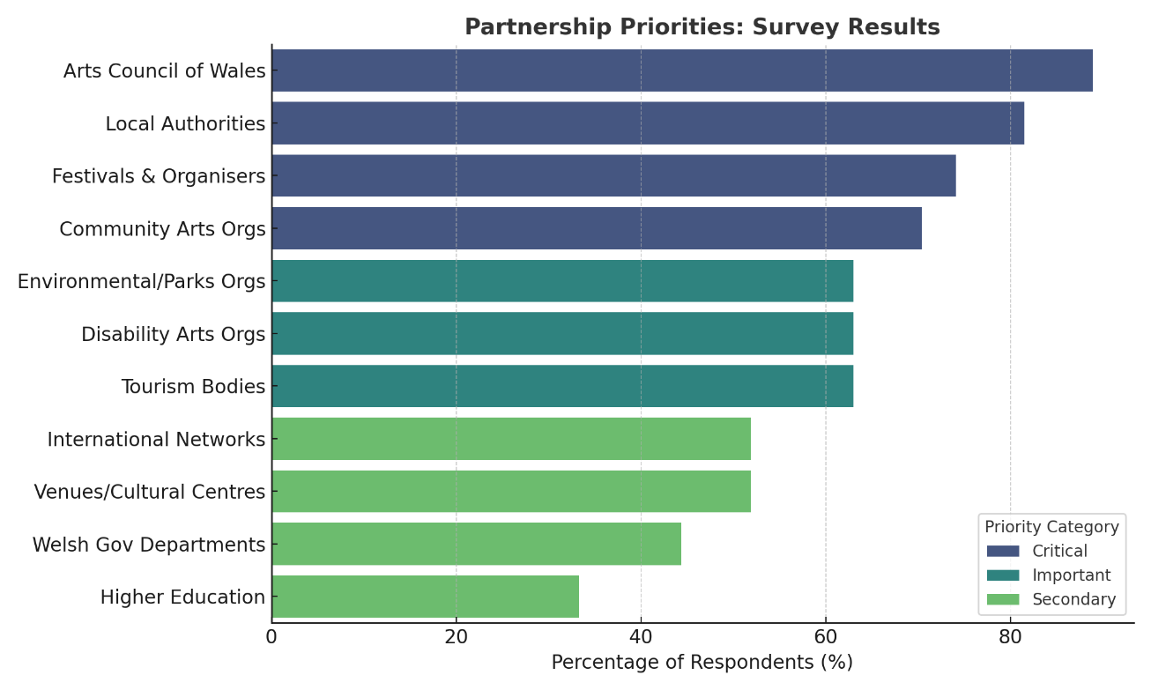
Critical partners (>70%):
- Arts Council of Wales: 88.9%
- Local authorities across Wales: 81.5%
- Festivals and event organisers: 74.1%
- Community arts organisations: 70.4%
Important partners (>60%):
- Environmental/parks organisations: 63.0%
- Disability arts organisations: 63.0%
- Tourism bodies: 63.0%
Secondary partners:
- International outdoor arts networks: 51.9%
- Major venues/cultural centres: 51.9%
- Welsh Government departments: 44.4%
- Higher education institutions: 33.3%
This prioritisation emphasises grassroots community connections and funding relationships over elite cultural institutions, suggesting bottom-up rather than top-down partnership strategy.
Collaboration Readiness
Survey respondents showed conditional willingness to collaborate:
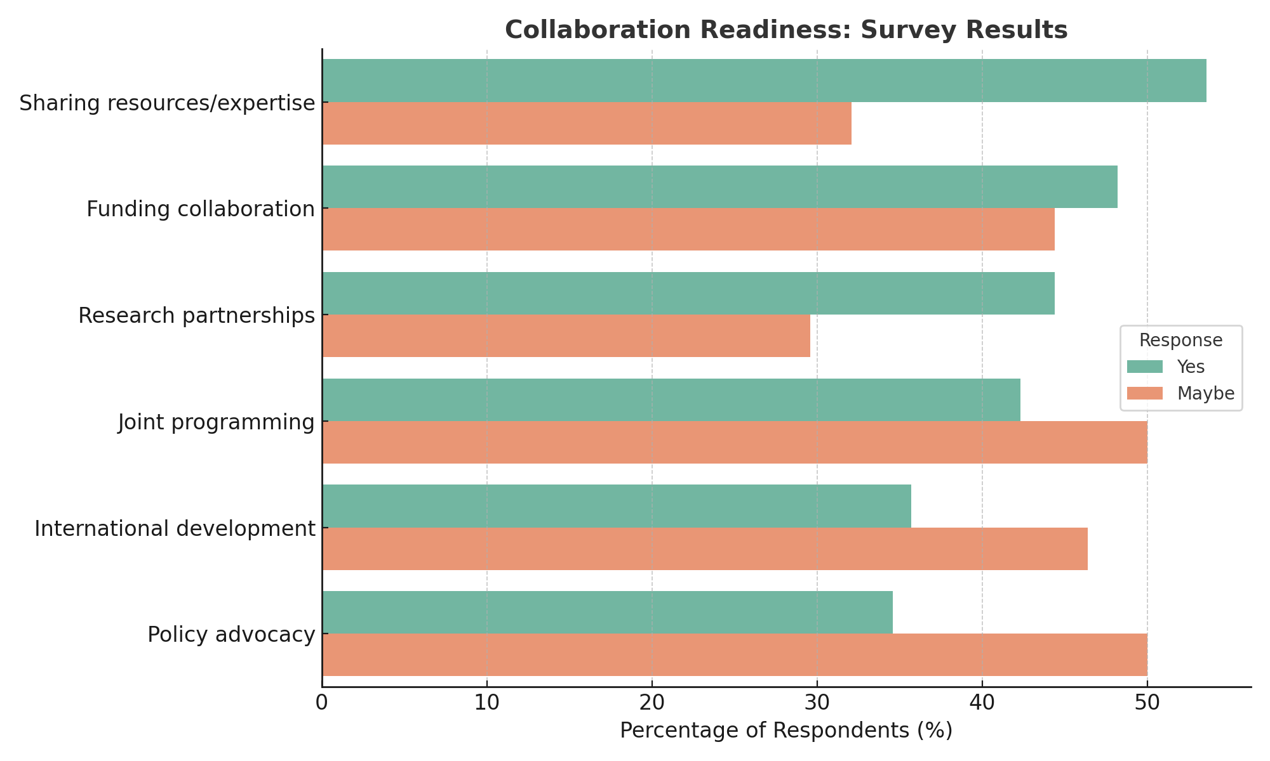
Highest interest:
- Sharing resources/expertise: 53.6% yes, 32.1% maybe
- Funding application collaboration: 48.2% yes, 44.4% maybe
Moderate interest:
- Research partnerships: 44.4% yes, 29.6% maybe
- Joint programming: 42.3% yes, 50.0% maybe
- International development: 35.7% yes, 46.4% maybe
- Policy advocacy: 34.6% yes, 50.0% maybe
High "maybe" percentages (29.6-50.0%) indicate interest contingent on well-designed frameworks addressing practitioner concerns about capacity, benefit distribution, and coordination burden.
Stakeholder perspective: External interviews noted "artists value Articulture, but there is a lack of strategic funding relationships and policy influence." This suggests collaboration infrastructure exists informally but needs formalisation to realise potential.

Organisational Transformation Requirements
The Capacity Crisis
When we spoke with Articulture's Directors, we heard deep commitment alongside frank acknowledgment of constraints. Articulture operates as a loose collective with a paid freelance structure. This has created trust, flexibility, artistic freedom. It's also financially unsustainable.
The organisation lacks:
- Salaried staff providing stability
- Dedicated business development capacity
- Resources for structured outreach
- Unable to engage in proactive policy advocacy
- Ability to plan long-term
One Director told us: "The lack of a stable, salaried team prevents Articulture from engaging in structured outreach, securing consistent funding, and professionalising operations."
Internal and external stakeholder interviews converge on a critical organisational challenge: Articulture cannot transform without capacity but lacks capacity to build transformation capability.
Transformation requirements
Directors identified "establish a salaried leadership team with focus on business development" as first strategic priority, explicitly framing this as "a first step in succession planning."
Articulture runs on passion, commitment and discretional effort. But as we've learned from the broader sector crisis, passion alone can't sustain organisations indefinitely.

Funding Priorities for Articulture
When we asked what would make the biggest difference, one answer dominated: ACW Core Revenue funding.
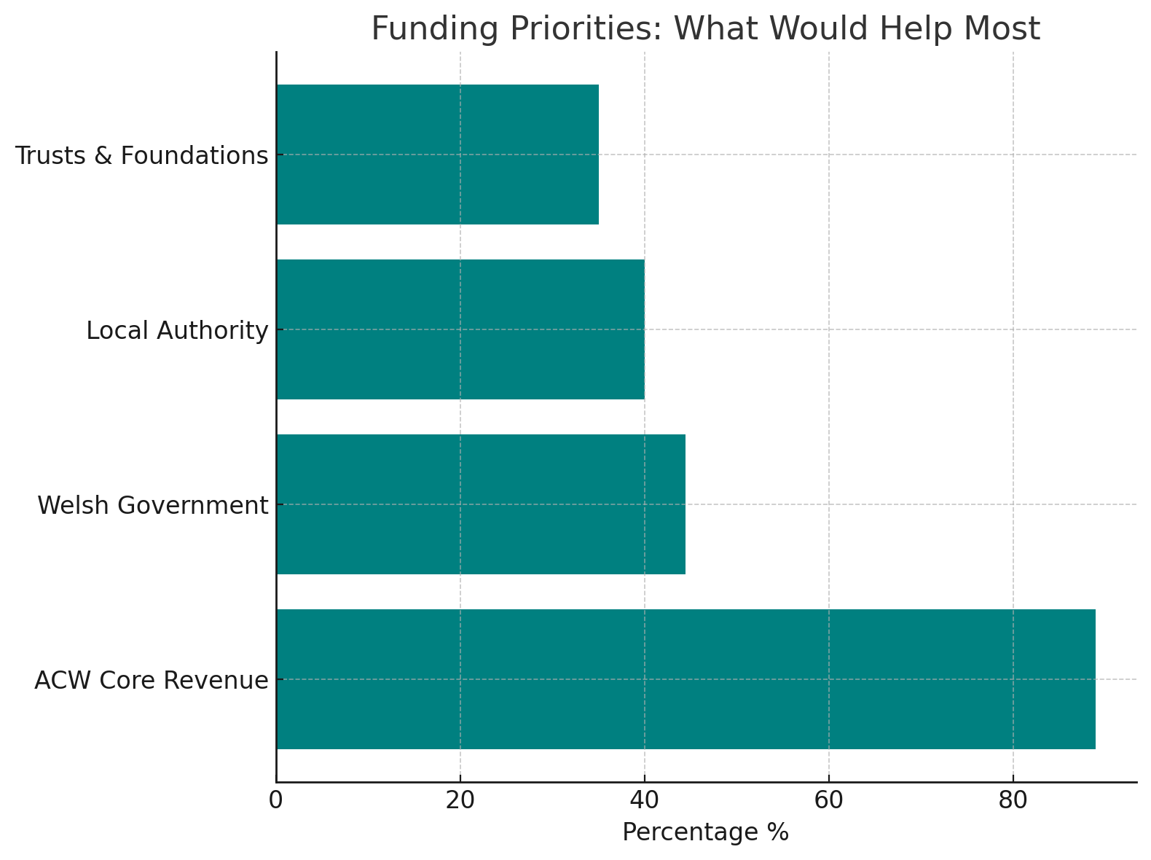
Weighted Priority Rankings:
- ACW Core Funding (1.65 - highest priority)
- Welsh Government (2.14)
- Local Authorities (2.84)
- Charitable Trusts (3.26)
88.9% of respondents identified partnership with Arts Council Wales as the highest priority. Nothing else came close.
Why such overwhelming support?
Stakeholders recognise that Articulture's current project-based funding model can't sustain the organisation or enable it to meet sector needs. Without core revenue support, Articulture operates in crisis mode - reactive, stretched thin, unable to build necessary infrastructure.
As one stakeholder put it: "Diversification is essential which will only be possible with Arts Council of Wales core revenue funding." Without core funding, Articulture can't build capacity. Without capacity, it can't diversify funding sources. Without diversified funding, it remains dependent on insufficient project grants.
External stakeholders were unanimous: Articulture needs stable funding to establish salaried leadership, dedicated business development, and capacity for strategic planning. While corporate partnerships, membership models, and consultancy services were discussed as possibilities, scepticism exists about their feasibility without core funding first.
Core revenue funding from Arts Council Wales breaks this cycle. It's not the only answer, but it's the necessary first step enabling everything else.

The Earned Income Question
Both survey data and stakeholder interviews converge on scepticism about earned income potential as significant revenue source:
Survey evidence:
- Only 11.1% definitely willing to pay for specialist services
- Only 11.1% willing to pay through annual membership
- 37% maybe depending on cost/value (conditional interest)
- 25.9% say not applicable to their situation
- 7.4% believe all support should be free
Investment capacity: Among those willing to specify amounts, 60% said "would depend on specific services" with most indicating £100-£500 annually – insufficient to fund core operations.
Stakeholder interview sentiment: Membership models received "mixed reactions" and "neutral to negative" sentiment with concerns about:
- Administrative burden of member management
- Risk of alienating smaller organisations unable to pay
- Creating transactional rather than mission-driven relationships
- Limited financial return relative to effort required
Director perspective: Internal interviews acknowledged "scepticism...about the feasibility of these income streams" (corporate partnerships, membership, consultancy).
Hybrid Approaches
Despite earned income scepticism, stakeholders identified "positive" sentiment toward "innovative approaches that align with Articulture's values":
Suggested hybrid models:
- Paid professional development opportunities (for those with capacity)
- Fee-based consultancy and advisory services (specialist expertise)
- Subsidised services with sliding scales (equity-maintained)
Critical condition: All hybrid approaches require core funding foundation. Without stable institutional support, earned income efforts divert scarce capacity from mission delivery while generating insufficient revenue to replace grant funding.

What Should Articulture’s Strategic Priorities Be?
We asked all stakeholders and survey respondents what Articulture's future priorities should be. Despite coming from different perspectives, their answers converged on remarkably similar themes.
Three Perspectives, One Message
External Stakeholders prioritised:
- Strengthening financial resilience through sustainable business models
- Investing in internal capacity for growth and innovation
- Enhancing advocacy and sector leadership
Internal Directors prioritised:
- Establishing a salaried leadership team with business development focus
- Strengthening funding diversification while securing core Arts Council support
- Defining a clear long-term role balancing artistic and financial sustainability

Survey Respondents want Articulture to focus on:
- Artist commissioning programme (75% want this, 86.2% see Articulture best placed to deliver)
- Year-round national network (67.9% want this, 82.8% value networking)
- Funding facilitation and advocacy (80.77% top concern)
- Artist mentoring/professional development (86.2% see Articulture best placed)
- Partnership development (67.9% want artist-venue partnerships)
What Success Looks Like
When we asked how Articulture should demonstrate impact, respondents prioritised tangible, visible outcomes:
Top metrics:
- Increased number of outdoor arts events across Wales
- More diverse artists/communities participating
- Skills development and career progression evidence
Secondary metrics:
- Improved funding success rates
- Enhanced international profile
- Better coordination/collaboration
- Policy influence outcomes
- Environmental sustainability improvements
The Pattern
All three groups - external stakeholders, internal directors, and survey respondents - are saying the same thing in different ways:
First: Fix the foundations (financial resilience, core capacity, stable staffing)
Then: Deliver tangible support (commissioning, networking, mentoring, funding access)
Finally: Lead the sector (advocacy, policy influence, systemic change)
Survey responses reveal what stakeholders actually value: direct support for artists, visible activity on the ground, and measurable career progression. The lower ranking of policy influence and systemic metrics isn't a rejection of advocacy - it's a statement about priorities and sequencing.
What This Means for Articulture
Stakeholders see Articulture as the natural leader for outdoor arts in Wales. They want this leadership to be artist-centred, pragmatic, and impact-driven. But they're also pragmatic about what's possible right now.
The strategic pathway is clear:
Short-term: Secure core funding and build internal capacity. Without stable infrastructure, none of the demand-driven priorities are deliverable at scale.
Medium-term: Establish Articulture as the national hub for outdoor arts - commissioning work, connecting artists, facilitating funding, building careers. Deliver visible, tangible support that artists and communities can see and feel.
Long-term: Translate this credibility and track record into sector leadership, policy influence, and systemic change. But only once the organisation has proven it can deliver consistently at grassroots level.
The mandate is clear: stabilise internally first, deliver externally second, lead systemically third. Each phase enables the next. Skip the foundation work, and the rest becomes impossible.

What Success Would Look Like for the Sector
Despite the crisis, people remain remarkably hopeful about what outdoor arts in Wales could become.
The Sector’s Vision of Success by 2030 would include:
- Financially sustainable sector with diversified funding streams
- Comprehensive geographic coverage eliminating identified inequities
- Strong artist support infrastructure (mentoring, commissioning, funding access)
- Active national network facilitating collaboration
- Enhanced policy visibility and advocacy capacity
- Inclusive, accessible programming
- Integration with environmental, tourism, and community development sectors
Critical success factors:
- Transformation from project-based to core-funded organisational model
- Shift from reactive to proactive policy engagement
- Formalisation of informal networks and relationships
- Development of internal capacity matching external expectations
The Sentiment Analysis
Vision for 2030:
Positive ████████████ 52.38%
Neutral █████████ 42.86%
Negative █ 4.76%
Biggest Dreams for Welsh Outdoor Arts:
Positive ██████████████ 70%
Neutral ██████ 30%
Negative 0%
Overall Stakeholder Sentiment:
Positive ██████████████ 65%
Neutral █████ 25%
Negative ██ 10%
When we asked people to envision success in 2030, responses were 52.38% positive, 42.86% neutral, only 4.76% negative. When we asked about their biggest dreams for outdoor arts in Wales, 70% of responses were positive, 30% neutral, zero negative.
People believe. They just need help getting from crisis to vision.
Here's what they told us they want to see:
"Wales could become a place where its culture is celebrated through outdoor arts by linking with wellbeing."
"I'd like to see outdoor arts in Wales being a brand - something that draws investment and tourism."
"A growing and thriving sector."
"More artists creating work, more choices when booking."
"International showcases and recognition for the Welsh sector."
"Lots more of it and good quality."
These aren't modest aspirations. People want Wales to be known for outdoor arts excellence. They want thriving artists, diverse programming, international recognition, cultural tourism, community wellbeing.
The vision exists. The passion exists. The commitment exists.
What's missing at the moment is the bridge from here to there.

The Counter-Question: If Not Articulture, Who?
Before concluding, we need to honestly ask: Could another organisation do this better, faster, or cheaper? We explored five alternatives.
Alternative | Estimated Cost | Viability | Key Issues
Expand an existing organisation's remit | £170-250k | Low | No organisation wants this; outdoor arts would be secondary mission; sector wouldn't trust it
Consortium model | £200k+ | Very Low | High coordination overhead; diffused accountability; slow decision-making
Outdoor Arts UK Welsh office | £150-200k | Low | Political/cultural concerns; ACW funding an England-based org; Welsh-specific needs deprioritised
Local authority coordination | N/A | Not viable | Severe budget constraints; no Wales-wide capacity; lack specialist expertise; LAs want support, not leadership
Sector self-organisation | £0 | Failing now | Current reality shows this doesn't work: sector health 3.67/7; 80.8% funding crisis; 62.9% survival concerns
Why Each Alternative Fails
Existing organisations: When we consulted with Theatr Genedlaethol Cymru, Creu Cymru, and major venues, none expressed interest or capacity. Most said: "This needs a specialist organisation focused solely on outdoor arts." Adding outdoor arts coordination would cost similar amounts but take longer to establish credibility and would always be secondary when organisational pressures arise.
Consortium model: Sounds collaborative but coordination overhead consumes resources without delivering outcomes. No single organisation has primary responsibility. Decision-making becomes slow and complex. Member organisations prioritise their own work over collective goals.
Outdoor Arts UK: We discussed this directly with OAUK. Their strong preference is to work in partnership with a Welsh organisation rather than compete with one. Questions remain about whether ACW would fund an England-based organisation and whether the Welsh sector would embrace what might be seen as external intervention.
Local authorities: Face severe budget constraints with cultural services especially vulnerable. They lack capacity for Wales-wide coordination and specialist expertise. Recent consultation showed LAs want support from national infrastructure, not responsibility for creating it.
Self-organisation: This is the current reality, and the research documents its failings: sector health barely adequate, funding crisis affecting 80%+ of practitioners, geographic inequality near-universal, and organisations stretched beyond capacity.
Why Articulture is the Best Option
After exploring alternatives thoroughly, Articulture emerges as the most viable option - not because it's perfect, but because:
- Alternatives cost similar amounts but deliver less
- Alternatives face greater feasibility and timeline challenges
- Articulture can mobilise quickly with existing relationships and infrastructure
- The community trusts Articulture specifically (54.3% have worked with them, 86.2% see them as best placed for key services)
- Dedicated focus matters for specialist sectors
- Wales-based, Wales-focused organisation is culturally and politically appropriate
If Articulture didn't exist, Arts Council Wales would need to create something very similar. Supporting an existing organisation with relationships, knowledge, and community trust is more efficient than building an alternative from scratch.
The sector needs specialist outdoor arts infrastructure. Articulture already is that infrastructure, it just needs resources to function sustainably.

Conclusion: The Evidence Demands Action
This research reveals something rare in strategic planning: genuine consensus. Artists, funders, partner organisations, local authorities, and Articulture's own directors all agree on what needs to happen next. When 100 voices from across a sector converge on the same conclusions, that clarity demands attention.
What the Evidence Shows
The Welsh outdoor arts sector is not failing because of lack of talent, ambition, or vision. It's failing because of structural fragility. 80.77% identify funding as their primary barrier. 62.9% worry about surviving the next five years. 89.7% see communities locked out of outdoor arts entirely.
This isn't a sector that needs to find its purpose. It needs resources to fulfill the purpose everyone already recognises.
What the Sector Needs from Articulture
The data is unambiguous:
- 86.2% see Articulture as best placed for artist mentoring and development
- 88.9% prioritise Arts Council Wales partnership as highest priority
- 75% want commissioning programmes
- 82.8% value networking infrastructure
But here's the paradox: Articulture is universally trusted to lead yet structurally unable to deliver at scale. The organisation operates as a freelance collective with project-based funding, stretched beyond capacity, reactive rather than strategic.
People don't need convincing about Articulture's value. They need Articulture to have the capacity to meet their documented needs.
The Transformation Pathway
Every stakeholder group identified the same sequence:
First: Secure core funding and build stable infrastructure. Without this foundation, everything else remains theoretical.
Second: Deliver tangible artist support at scale - commissioning, mentoring, funding facilitation, career development.
Third: Lead sector advocacy and policy influence from a position of proven grassroots delivery.
This isn't aspirational thinking. It's pragmatic sequencing based on documented demand and organisational capacity.
Why Core Funding Changes Everything
Arts Council Wales core revenue funding breaks the cycle that currently traps Articulture:
Without core funding → can't build capacity → can't diversify income → remains dependent on insufficient project grants → cycle continues.
Core funding enables: salaried leadership → strategic development → diversified revenue → sustainable operations → scaled delivery.
One stakeholder captured it perfectly: "Diversification is essential which will only be possible with Arts Council of Wales core revenue funding."
The Geographic Imperative
Nearly nine in ten stakeholders identify communities without access to outdoor arts. North Wales, Southwest Wales, rural Mid Wales - the places where free, accessible cultural experiences could have the most impact are the places least served.
Any credible strategy must explicitly address this inequality, not as secondary concern but as primary mission.
What Success Actually Looks Like
When asked about impact metrics, stakeholders prioritised visible, people-centred outcomes:
- More outdoor arts events across Wales
- More diverse artists and communities participating
- Measurable skills development and career progression
Not strategy documents. Not policy wins. Not international showcases. Tangible change that artists and communities can see and feel.
This tells us something important: stakeholders will judge Articulture by what it delivers on the ground.
The Alternative Reality
We examined whether another organisation could fulfil this role. Every option - expanding an existing remit, creating a consortium, inviting external organisations, relying on local authorities, or allowing sector self-organisation - proved less viable than supporting Articulture's transformation.
If Articulture didn't exist, someone would need to create something very similar. Supporting an organisation with existing relationships, knowledge, and community trust is more efficient than building alternatives from scratch.

The Window of Opportunity
The sector faces crisis, but that crisis has created unusual clarity. Stakeholders know what they need, they know who's best placed to provide it, and they're ready to support transformation. This alignment won't last indefinitely.
Current conditions favour action:
- Documented need (80.77% funding crisis)
- Stakeholder support (65% positive sentiment)
- Strategic clarity (consensus across all groups)
- Leadership readiness (directors committed to change)
What Happens Next
This research provides the evidence base for transformation. The data is clear, the mandate is strong, the pathway is defined. What remains is securing the resources to bridge from crisis to sustainability.
Core funding from Arts Council Wales is not the only answer, but it is the necessary first step enabling everything else. Without it, all other recommendations remain impossible. With it, Articulture can become what the sector already believes it should be: the national infrastructure organisation for outdoor arts in Wales, delivering tangible support to artists and communities while advocating for systemic change.
The Welsh outdoor arts sector has done its part. It has articulated needs, identified solutions, and expressed readiness to engage. Now the question moves from "what should happen?" to "who will make it happen?"

Appendices
Appendix A: Survey Demographics Summary
Strategic Survey (n=38)
- Individual artists/practitioners: 16.2%
- Small arts organisations (<£50k): 8.1%
- Medium organisations (£50k-£250k): 18.9%
- Large organisations (>£250k): 18.9%
- Venue/festival organisers: 13.5%
- Local authority: 5.4%
Community Survey (n=51)
- Artists/creatives: 63.8%
- Arts organisation staff: 29.8%
- Audience members: 27.7%
- Community group members: 8.5%

Please refer to appendices E, F and G for full survey and interview question sets.
Age distribution: Predominantly 45-64 (sector survey: 44%), 25-64 (public survey: 84.4%)
Language: 59.4% English only, 34.4% bilingual English/Welsh

Appendix B: Stakeholder Interview Participants
- Rosie Strang, Small Woods
- Sioned Edwards, National Eisteddfod of Wales
- Laura Drane, Arts Council Wales
- Lisa Matthews, the Arts Council of Wales
- Lucy Medleycott, ISACS
- David Doust & Sho Shibata, Outdoor Arts UK
- Louise Miles-Davis, Creu Cymru
- Nicola Edwards, Awen Cultural Trust
- Emma Evans, WMC
- Iwan Glyn Williams, Ffiwsar
- Zoe Munn, Freelance Producer, Greenman Festival
- All Articulture Directors (internal interviews)

Appendix C: Methodology Notes
Research Design
This research employed a mixed-methods approach combining quantitative survey data with qualitative stakeholder interviews to triangulate findings and provide both breadth and depth of insight.
Survey Methodology
Distribution:
- Online survey platform – Survey Monkey
- Distributed through established arts networks and professional bodies
- Promoted via Articulture's website and social media channels
- Direct email distribution to Articulture's existing database and networks
- Distribution period: June – September 2025
Sample:
- Total responses: 89
- Respondent categories: Artists, arts organisations, funders, local authorities, and other sector stakeholders
- Geographic distribution: Across Wales
Survey Design:
- Mix of closed questions (Likert scales, multiple choice, ranking exercises) and open-ended responses
- Priority ranking questions using weighted scoring (1 = highest priority, 5 = lowest priority)
- Percentage calculations based on "top 3 selections" where multiple choices were permitted
- Questions covered: strategic priorities, funding preferences, service needs, impact metrics, and organisational role
Limitations:
- Self-selecting sample may reflect more engaged stakeholders

Interview Methodology
Sample:
- Semi-structured interviews conducted with 11stakeholders
- Articulture Directors (internal perspective)
- External stakeholders: funders, partner organisations, venue directors, sector leaders
Process:
- Interviews conducted by Sequoia (Anne McReynolds and Áine McVerry)
- Duration: 30-60 minutes each
- Conducted February - September
- Format: video call
Interview Structure:
- Semi-structured format allowing for flexible exploration of themes while maintaining consistency across interviews
- Core topics: Articulture's current role, strategic priorities, funding challenges, sector needs, and future opportunities
- Responses recorded via notes/audio recording/transcription
Analysis Approach
Quantitative Analysis:
- Weighted priority rankings calculated using mean scores (lower score = higher priority)
- Percentage calculations for multiple-choice and "select top 3" questions
- Statistical analysis of rating scales and demographic variables
Qualitative Analysis:
- Thematic coding of open-ended survey responses and interview transcripts
- Identification of recurring themes, patterns, and divergences across stakeholder groups
- Direct quotations selected to illustrate key themes (anonymised where appropriate)
- Triangulation between survey data and interview findings to validate insights
Integration:
- Mixed-methods synthesis combining quantitative patterns with qualitative depth
- Cross-verification of findings across data sources
- Identification of consensus areas and points of tension or divergence

Appendix D: Key Data Tables
Sector Health Ratings (1-7 scale, 1=very poor, 7=excellent):
- Overall health: 3.67
- Artist support: 3.27
- Geographic reach: 3.27
- Audience engagement: 3.37
- Inclusion/accessibility: 3.77
- Collaboration: 3.53
Top 5 Challenges (% ranking as #1):
- Funding/sustainability: 80.77%
- Limited venues/spaces: 21.43%
- Marketing/audience development: 10.53%
- Skills gaps: 8.33%
- Coordination: 0%
Priority Services (% selecting):
- Artist mentoring: 86.2%
- Commission opportunities: 75.9%
- Networking in Wales: 65.5%
- Venue finding: 55.2%
- Policy advocacy: 41.4%
Willingness to Pay:
- Yes for specialist services: 11.1%
- Yes through membership: 11.1%
- Maybe depending on value: 37.0%
- Only subsidized: 7.4%
- Should be free: 7.4%
- Not applicable: 25.9%
Report prepared: October 2025
Total respondents: 89 survey responses + 11 external stakeholder interviews + 6 internal director interviews

Appendix E: Stakeholder Interview Questions
Articulture Stakeholder Interview Questions (issued in advance)
Topic: Discussion on Articulture’s transformation towards a sustainable business model
Duration: 30 minutes
Thank you for taking the time to talk with us. We’re looking forward to hearing your views on how Articulture can best transform to ensure the continuation and growth of its work on behalf of Wales’s outdoor arts sector and artists in the coming years.
The areas we will be covering are below and we’re sharing these in advance to give you time to reflect, so that we have a relaxed, open conversation.
We really appreciate your input—it will be extremely helpful in informing how Articulture moves forward.
Anne & Áine
  - How would you describe Articulture’s current role in the outdoor arts sector?
  - What are the organisation’s key strengths and the areas in which it excels?
  - What do you consider Articulture’s main challenges to be in terms of operations, funding, or growth?
  - Are there emerging trends or opportunities in outdoor arts that could be opportunities for Articulture?
  - What funding sources do you think Articulture should prioritise for futurestability?
  - Do you see any value in transitioning to a membership model? What would make this appealing to artists and organisations?
  - What hybrid approaches could balance mission-driven work with financial sustainability?
  - What do you think Articulture’s top three strategic priorities should be over the next five years?

