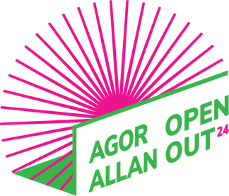
Budgeting your show

In the table below are some useful suggestions for headings that you need to think about when you are planning your budget. These are guidelines only and you may want to add your own.

Please note: Articulture is not VAT registered. If you are then please make sure all your costings include VAT.

Access costs. You might want to think about what would be helpful during the making of you show and on tour.
.
Please tick what you think might be relevant to you.
NAME: PROJECT NAME:

Rehearsal costs | Per day/week x how many days/weeks | Total cost
Performers
Director /other professionals needed in rehearsal space
Hire of Rehearsal space
Design fees/ other professional fees
Making costumes/set and props
Any other costs
 |  | Total up to £6000

Access Costs
Access costs for rehearsal/ making of show:
Notetaker
BSL interpreter
Driver
OTHER – please specify
Access costs for tour
Notetaker
BSL interpreter
Driver
OTHER – please specify
Audio visual consultation/ training /development of elements in piece

