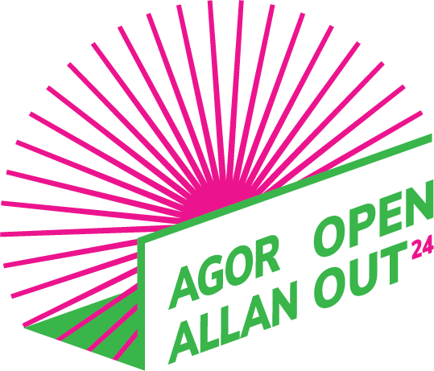 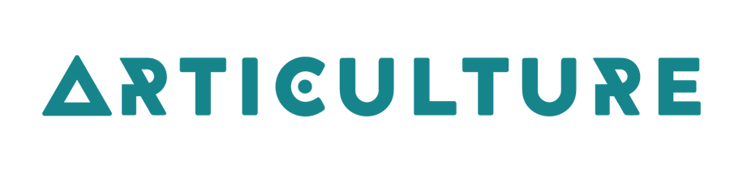
#AgorAllan2024 #OpenOut2024
Opportunities for artists in Wales to create and tour new outdoor arts
Written by Julie Ann Heskin 23/10/2023

Application Guidelines
This is a guide that describes what artiist and work we are looking for. It also answers questions you might have.

About us:
Wales Outdoor Arts Consortium has 9 partners who are venues and festivals across Wales. Each commission could be booked for a minimum of 6 shows going up to 9 shows for 2024.
The partner venues are all different. You might perform in a town centre, outside an arts centre or theatre, in a park or in the grounds of a property.

We are especially looking for applications from:
- the Deaf, disabled and/or neurodivergent community
- artists wanting to work in the Welsh Language and\or bilingually.

Who can apply?
- You can apply as the lead artist if you live in Wales.
- You need to tell us who you want to work with and if they are from in Wales, the UK or international.
You must:
- Be able to work legally in the UK
- Have or be able to get the right insurance cover.

Your Idea:
- Must take place outdoors
- Needs to be something that people can watch and /or take part in. For example, it might have singing, dancing, acting, music, clowning or circus in it.
- We are looking for an idea that brings a diverse range of people to work together.
- If there are spoken parts in the show they must be in Welsh and or bilingual i.e Welsh and English.
- Needs to be as inclusive as possible i.e relevant to a wide range of people.

How we work.
- Be ready to work with us in a positive and open way, sharing and learning together.
- We want you to speak or email with us regularly to tell us how you are doing. This will help to solve problems and plan properly.
- We also will ask you how the project went after it has finished.

Frequently asked questions

How big should the work be?
We don’t have a rule for this but commissions are usually small scale - this means for under 200 people to watch each time you perform usually with 1 or 2 performers in it.

How much money can I request?
You can ask for up to £6000 inclusive of VAT to create the work. This can be in addition to other funds you already have. You can ask for extra money to develop BSL and/or audio description for your performance. If you have access needs talk to us about what support you would need for both the making of the performance and touring.
What do I need to include in my budget?
Your budget should show all the money needed to develop and rehearse your idea.
Include:
- Artists/creative rehearsal (a daily rate is useful here)
- Rehearsal space if you need one
- Design fees
- Making your costumes and building your set and props
- If you are VAT registered do not include VAT that you can reclaim.
- Access costs for making your work for example a notetaker, BSL interpreter, support worker, driver.

What costs should be covered in my performance fee?
Your total performance fee for one day can be between £400 - £1000 and will depend on how big it is and how many people are in it.
Things to think about when you are working this out:
- How many shows a day you can do
- How far you have might have to travel
- Accommodation if needed overnight
- Artists fees for the day.

Do I need to include technical costs in my performance fee?
You will be performing at busy festivals and events and the venue might not always be able to supply staff/ crew, power or a PA. You need to be self-sufficient and plan what you need carefully. This includes stage management or technical support during your time on site if you think you need it along with sound or computer equipment and power for them.

Is there any extra help can I have?
Before you apply you can book a producer session to help you explore and refine your idea. This will be offered when we have our first chat.
When you are make your performance you can choose a mentor to work with.
A mentor is an experienced specialist and the help they could offer might include costume, working on the story you are telling, prop making, directing, Welsh/BSL, movement etc.
If you get the commission we will talk with you to about your ideas and help you work out who is the best person. It could be one or more people, offering up to 3 days support in total.

Articulture will also provide a producer. The producer will help you organise and book your tour. We can also offer help with access needs.

Can I apply for money to tour an existing outdoor piece?
No. We cannot support any projects that have already toured in Wales.

Can I apply to redevelop an existing piece?
Unlikely. This commission is for the development of new outdoor work. You would need to tell us how it had changed for us to consider it.

I have received some development money from the Arts Council of Wales to research my idea; can I still apply for funds to create my piece?
Yes, as long as your R&D process is clearly separate from your creation process.

If my idea is chosen, can I still tour to other events that are not part of the WOAC network?
You must give the WOAC partners first choice booking the year you have been commissioned.

I already have some funds in place from other sources - can I still apply for support?
Yes, please explain who else has agreed to support you and if there are any conditions.

I have applied for some funding but I don’t know yet whether it is confirmed; can I still apply to you?
Yes, but tell us when you will know the outcome of your application.

Can I apply by video or audio recording?
Yes, we welcome video and audio applications. Please make sure your video answers the questions from the application form fully, and include your budget. We can support you to apply by video using BSL and/ or a BSL translator if needed. You can also apply with an audio recording or a recorded Zoom interview.

Can I have help with my application?
Yes, we can help you with this. We are working closely with ‘Taking Flight’ this year to
offer help with any access needs, just get in touch with us and we can arrange the help you need.
DEADLINE: 12noon, Friday 2 February 2024

What happens after I send you my idea?
23 February 2024 | 4 March 2024 | Beginning of May | Beginning of June
We will let you know if you have been chosen. | You will start developing your idea with support from Articulture | Ready for a public rehearsal | Ready to go on tour

If you have any further questions please contact us:
Email - julieann@articulture-wales.co.uk
Phone (calls or text) - 07890681212
Facebook - www.facebook.com/ArticultureWales
Twitter - https://twitter.com/Articulture_
Instagram - https://www.instagram.com/articulture_wales/
Tour booking in progress:

Consortium Partner | Dates all TBC | Environment
Public Rehearsal | May bank holiday | Market town, park
The Welfare, Ystradgynlais | 2 /3/ June or August | Urban park or around outside of theatre
Taliesin, Swansea | 1 / 2 June 2024 | Around outside of arts centre, in theatre courtyard/ alongside river wharf
Riverfront, Newport ,Big Splash | 20/21 June 2024 | Urban streets around theatre
Pontio .Bangor | 20 July 2024 | Around the outside of the theatre
Theatr Clywd | 2 /3 /4 /August | Urban park
National Eisteddfod of Wales. | 3-10th August | Pontypridd Ynysangharad Park
Blackwood Miners’ Institute, Caerphilly | 5-11th August | Parks in Caerphilly
Awen Trust, Bridgend | Summer | Park or urban town centre
Other venues in Wales x3 | TBC | Park or town centre

