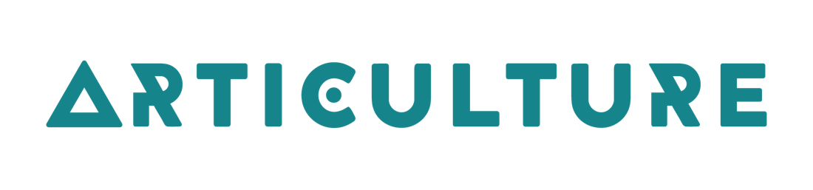
#OpenOut2023
Opportunities for artists in Wales to create and tour new outdoor arts

Application Guidelines
This is a guide that describes what kind of person we are looking for. It also answers questions you might have.

About us:
Wales Outdoor Arts Consortium has 11 partners who are venues and festivals across Wales. Each commission could be booked for a minimum of 6 shows going up to 12 shows for 2023.
We have 2 strategic commissions for:
- the D/Deaf disabled community
- work created and performed in Welsh
- There is also a third open commission for all artists

Who can apply?
- You can apply as the lead artist if you live in Wales
- You need to tell us who you want to work with and if they are from in Wales, the UK or abroad
- You can apply for a strategic commission if you are D/deaf or Disabled and live in Wales
- You can apply for a strategic commission if you want to make your work in Welsh and live in Wales

You must
- Be able to work legally in the UK
- Have or be able to get the right insurance cover

Your Idea
Must take place outdoors
- Needs to be something that people can watch and /or take part in. For example, it might have singing, dancing, acting, music, clowning or circus in it
- We are looking for an idea that brings different people to work together
- If there are spoken parts in the show, they must be in both Welsh and English. If it is booked by the Eisteddfod all of the spoken parts will need to be in Welsh.

How we work
- Be ready to work with us in a positive and open way, sharing and learning together
- We want you to speak or email with us regularly to tell us how you are doing. This will help to solve problems and plan properly
- We also will ask you how the project went after it has finished

Frequently asked questions

How big should the work be?
We don’t have a rule for this but commissions are usually small scale - this means for under 500 people to watch each time you perform.

How much money can I request?
You can ask for up to £5,500 inclusive of VAT to create the work. This can be in addition to
other funds you already have.

What do I need to include in my budget?
Your budget should show all the money needed to develop and rehearse your idea.
Include:
- Artists/creative rehearsal (a daily rate is useful here)
- Rehearsal space if you need one.
- Design fees for example designing of props, costumes, set and sound
- Making your costumes and building your set and props
- If you are VAT registered do not include VAT that you can reclaim.

What costs should be covered in my performance fee?
Your total performance fee for one day can be between £400 - £1000 and will depend on how big it is and how many people are in it.
Things to think about when you are working this out:
- How many shows a day you can do
- How far you have might have to travel
- Accommodation if needed overnight
- Artists fees for the day.

Do I need to include technical costs in my performance fee?
You will be performing at busy festivals and events and the venue might not always be able to supply staff/crew, power or a PA. It is best to be as self-sufficient as possible and plan what you need carefully. This includes stage management or technical support during your time on site if you think you need it.

Is there any extra help can I have?
You can choose to work with either a mentor or a producer.
A mentor is an experienced specialist who can help you make your work. Help could include costume, working on the story you are telling, prop making, directing, Welsh/BSL, movement etc.
A producer can help you organise and book your tour.
If you get the commission, we will talk with you to about your ideas and help you work out who is the best person. It could be one or more people, offering up to 3 days support in total.
We can also offer help with access needs.

Can I apply for money to tour an existing outdoor piece?
No. We cannot support any projects that have already toured in Wales.

Can I apply to redevelop an existing piece?
Unlikely. This commission is for the development of new outdoor work. You would need to tell us how it had changed for us to consider it.

I have received some development money from the Arts Council of Wales to research my idea; can I still apply for funds to create my piece?
Yes, as long as your R&D process is clearly separate from your creation process.

If my idea is chosen, can I still tour to other events that are not part of the WOAC network?
No. You must give the WOAC partners first choice booking the year you have been commissioned.

I already have some funds in place from other sources - can I still apply for support?
Yes, please explain who else has agreed to support you and if there are any conditions.

I have applied for some funding but I don’t know yet whether it is confirmed; can I still apply to you?
Yes, but tell us when you will know the outcome of your application.

Can I apply by video?
Yes, we welcome video applications. Please make sure your video answers the questions from the application form fully, and include your budget. We can support you to apply by video using BSL and/ or a BSL translator if needed. You can also apply with an audio recording or a
recorded zoom interview.

Can I have help with my application?
Yes we can help you with your application. We are working closely with ‘Taking Flight’ this year to offer help with any access needs, just get in touch with us and we can arrange the help you need.
Get in touch with us by Friday 3 March if you are interested in applying. Getting in touch
sooner is better than waiting until later.

What happens after I send you my idea?
The deadline to send us your application is 5pm Friday 17 March.
The WOAC partners will choose the 3 commissions by Friday 31 March.
If your idea is chosen by the partners, you will start working on your idea with support from Articulture from Monday 10 April.
We think that touring will start in July 2023.

Please contact us by:
Email - julieann@articulture-wales.co.uk
Phone (calls or text) - 07890681212
Facebook - www.facebook.com/ArticultureWales
Twitter - https://twitter.com/Articulture_
Instagram - https://www.instagram.com/articulture_wales/

