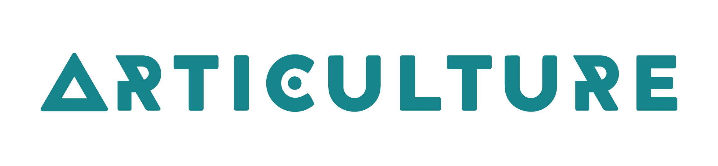
#OpenOut2023
Opportunities for artists in Wales to create and tour new outdoor arts

Application Form

Please tell us about you or your company by filling in the boxes next to the questions
What is your name/ the name of your company?
Who is the main person to contact?
What does the main contact do if in a company?
What city/region do you live in?
What is your address?
what is your Telephone number?
What is your email address?
What is your website
address?
Now tell us about your project/ idea by filling in the boxes next to the questions
What is your project / idea called?
What is it about? (20 words max)
How would you describe your idea ie: dance, acting, clowning, dance....
Is your project static or moving?
Is this project led by an artist who wants to work in the Welsh language? |  | Yes / No
Is this project led by a D/deaf or Disabled artist? |  | Yes / No
What are the language(s) of the work?
ie Welsh, English, BSL?

Budget
Total amount of money requested from Articulture |  |  | £
Total amount of money requested from other funders or investors Please tell us if you have got this money, or the date that you will be told. |  |  | £
Total costs of making your project  (including money requested from Articulture) |  |  | £

1. Please tell us about your proposal/ idea. You can use up to 300 words

2. Please tell us about your company / artists / collaborator. Tell us what previous experience in creating outdoor work you have (you can write up to 150 words)

3. Budget

3.1 Please attach a budget of all your costs to make your project happen (if you are VAT registered, please show this net of VAT this means with the VAT included)
Please tell us if any other funders or investors are giving you money towards your project. Tell us if you already have that money or when you will get it.

3.2 Are you VAT registered? Yes [ ] No [ ]

3.3 What is the performance fee (per day)?

£

4. Production Plans

4.1 Approximately how long will your show be?

4.2 What technical support and equipment will you need? For example PA, power, lighting, overnight security, steward support. If you have made a plan with technical needs, please attach it.

4.3 How many shows can you normally perform per day?

4.4 How many people will be in the show / performance?

4.5 Do any members of your company have any access requirements?
Please explain what you will need

4.6 How long is your ideal rehearsal period?

4.7 What are your rehearsal / development plans? e.g. dates, locations
(please note we will discuss with you the possibility of a public rehearsal)

4.8 Please let us know of anything you have already decided to do in 2023 that would mean you are unavailable for tour dates.

5. Mentoring and production support.

What help would you need to make your project. Would you like the support of a mentor or producer. If yes, is there someone you know you would like? (150 words max.)

6. Marketing material
Images, drawings and visual material about your project are very useful so we can imagine what your project will look like. Please attach any you want to send and put your name or the name of your company and your show on them.

7. References
You do not have to supply a reference with this proposal, but if you want you can. This would be especially useful if you are an artist or company new to outdoor arts in Wales.

Contact
For further information, please contact me by:
Email - julieann@articulture-wales.co.uk
Phone (calls or text) - 07890 681212
Facebook - www.facebook.com/ArticultureWales
Twitter - https://twitter.com/Articulture_
Instagram - https://www.instagram.com/articulture_wales/

