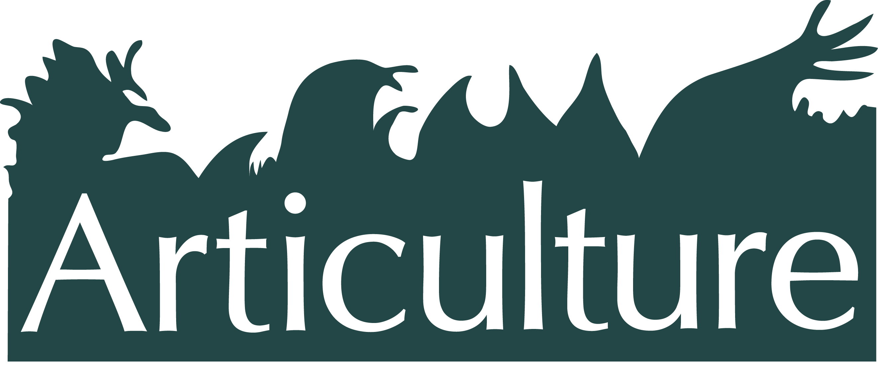

**Invitation**

**The Great Outdoors Expedition 2014**

**- {Adventure No.1} -**

***Exploring partnerships for Outdoor Arts***

***Wye Valley River Festival***

***Monmouth Shire Hall, Fri 9th May, 1 – 7pm***

Articulture invites you to the first of three adventures in 2014, an inspirational day out exploring the crafting of collaborations to create outdoor arts in Wales. It takes place at the new Wye Valley River Festival, born out of an exceptional alliance between the Wye Valley Area of Outstanding Natural Beauty, the renowned Desperate Men, Welsh and English artists, and local communities.

High quality and innovative outdoor arts rely on collaborative vision and support. Join outdoor artists, producers, managers, venues, landowners and funders (all interested in exploring partnerships) to make connections, share experience, and get inspired by those taking the lead. Situated at Monmouth’s 16th century Shire Hall, with ventures out into the heart of the festival to see work.

**Speakers include:** [**Desperate Men**](http://www.desperatemen.com/_) (outdoor artists & producers inc ‘Battle for the Winds’ - opening of the London 2012 Olympic and Paralympic Sailing event); [**Wye Valley** **AONB**](http://www.wyevalleyaonb.org.uk/_); [**Arts Council Wales**](http://www.artswales.org.uk/_); [**National Theatre Wales**](nationaltheatrewales.org/%E2%80%8E); [**NoFit State Circus**](http://www.nofitstate.org/_); [**Mr and Mrs Clark**](http://www.mrandmrsclark.co.uk/_); [**Marc Rees**](http://www.r-i-p-e.co.uk/_) (‘Adain Avion’ - commission for London 2012 London Olympic and Paralympic Games, and upcoming ‘Raw Material: Llaregubb Revisited’ for National Theatre Wales and BBC Cymru Wales); and Phillippa Haynes, **Wye Valley River Festival**. Attendees include **Natural Resources Wales** and **National Trust**.

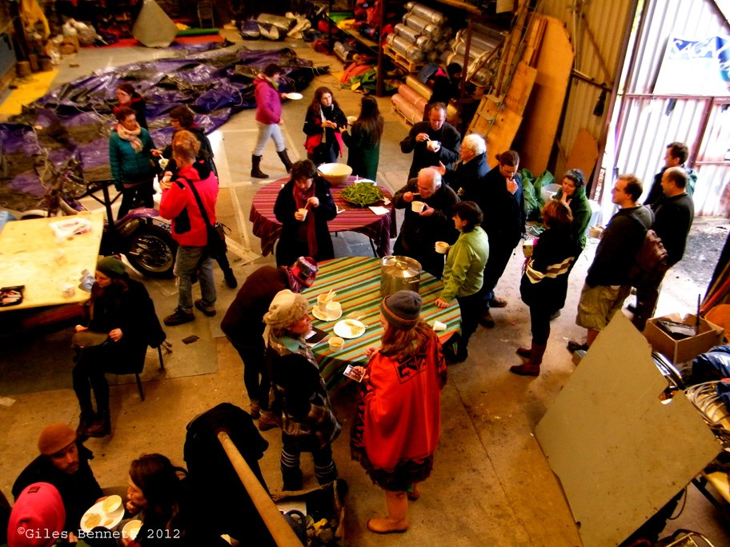

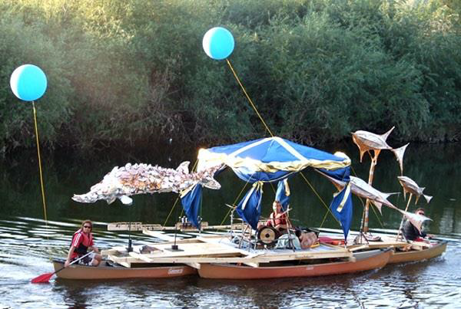

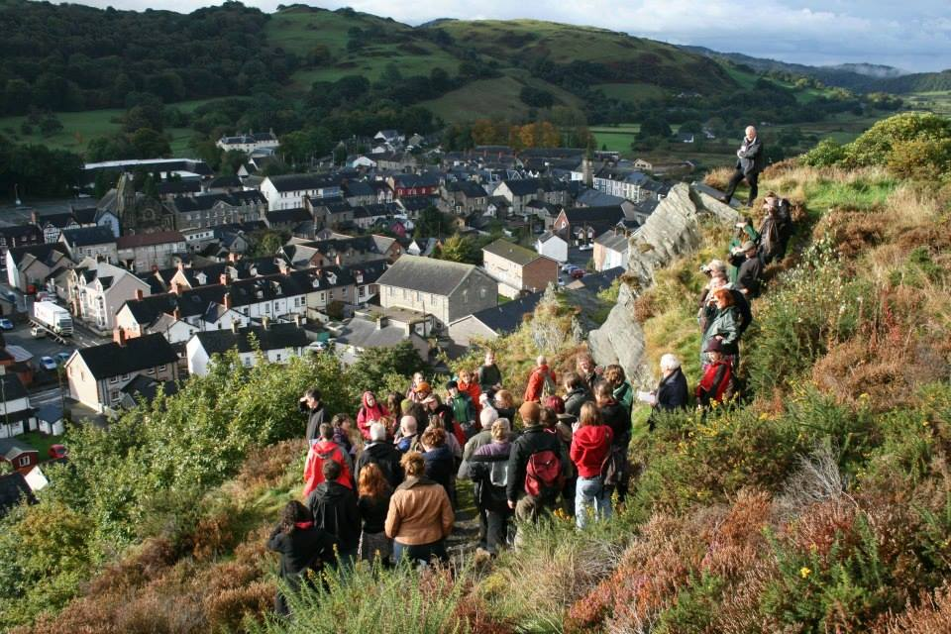

**Booking**

Book online [here](http://www.seetickets.com/Event/exploring-partnerships-for-outdoor-arts/shire-hall/777023)

Tickets: £28 for independent practitioners, £40 for organisations. Includes light lunch and refreshments. Participation in festival parade 6 – 7pm optional.

**Getting there**

Shire Hall, Agincourt Square, Monmouth, NP25 3DY. T: 01600 775257

**Accommodation**

Hotels, hostels, B&B’s visit [here](http://www.monmouth.org.uk/)

Camping Fri – Sun £4 per person per night + bunting! Via Articulture

**For more info - 07966 071073** [**www.articulture-wales.co.uk**](http://www.articulture-wales.co.uk)

**About the Wye Valley River Festival (WVRF)**

Throughout May 2014 the Wye Valley in Wales will come alive with a series of amazing riverside events for the inaugural **Wye Valley River Festival**, a new initiative by the [Wye Valley Area of Outstanding Natural Beauty](http://www.wyevalleyaonb.org.uk), in collaboration with artistic directors Desperate Men.

Working with Welsh and English artists and local communities, the festival will celebrate the area’s history & heritage while stimulating serious debate about topical issues affecting the river landscape.

**Articulture commission at the WVRF**

As part of the WVRF Articulture, in collaboration with Desperate Men, have commissioned a new small-scale piece of outdoor work.

The chosen piece is a site responsive duet dance by [Chloe Loftus Dance](http://www.chloeloftus.co.uk). Specialising in pop-up performances over ten years recent accolades include associate artist at the Wales Millennium Centre and a nomination for a Theatre Critic Wales Award for Best Small Scale Dance Production in 2013.

**Other opportunities for outdoor arts practitioners at WVRF**

**Articulture Encounter, Sun 11th May, 2 – 10pm, Llandogo, free.** A more informal chance to network, share food, see performances and even participate in the show! See [Articulture](http://www.articulture-wales.co.uk) for details.

**Fire & Flame workshop, Sat 12th April, Monmouthshire.** One-day workshop with international pyrotechnic experts ‘And Now’ Book with [office@wyevalleyaonb.org.uk](mailto:office@wyevalleyaonb.org.uk)

**About Articulture**

[Articulture Wales](http://www.articulture-wales.co.uk) is an arts organisation that creates opportunities to bring together arts practitioners and promoters in Wales to support innovation, collaboration and production of unique outdoor performance.

Articulture are a project-funded collective of four freelance arts practitioners.

We dream, create, and manage around our kitchen tables, as well as connecting and collaborating on the ground across Wales.

Articulture’s latest project **‘The Great Outdoors Expedition’** is a series of opportunities mapped out across Wales and beyond in 2013/14, targeted at Wales based arts practitioners, funders, development officers, festivals and venues. It includes bursaries, events, mini encounters and new small-scale commissions. The Expedition is supported by the Arts Council of Wales.

**Other upcoming adventures in 2014**

**-{Adventure 2}-** Theme tbc,Wed 6th August, The National Eisteddfod, Millennium Coastal Park, Llanelli.

**-{Adventure 3}-** Date/theme tbc, October, Grand opening of the Pontio Arts & Innovation Centre, Bangor.

For all upcoming opportunities sign up for the Articulture newsletter by emailing [info@articulture-wales.co.uk](mailto:info@articulture-wales.co.uk).



