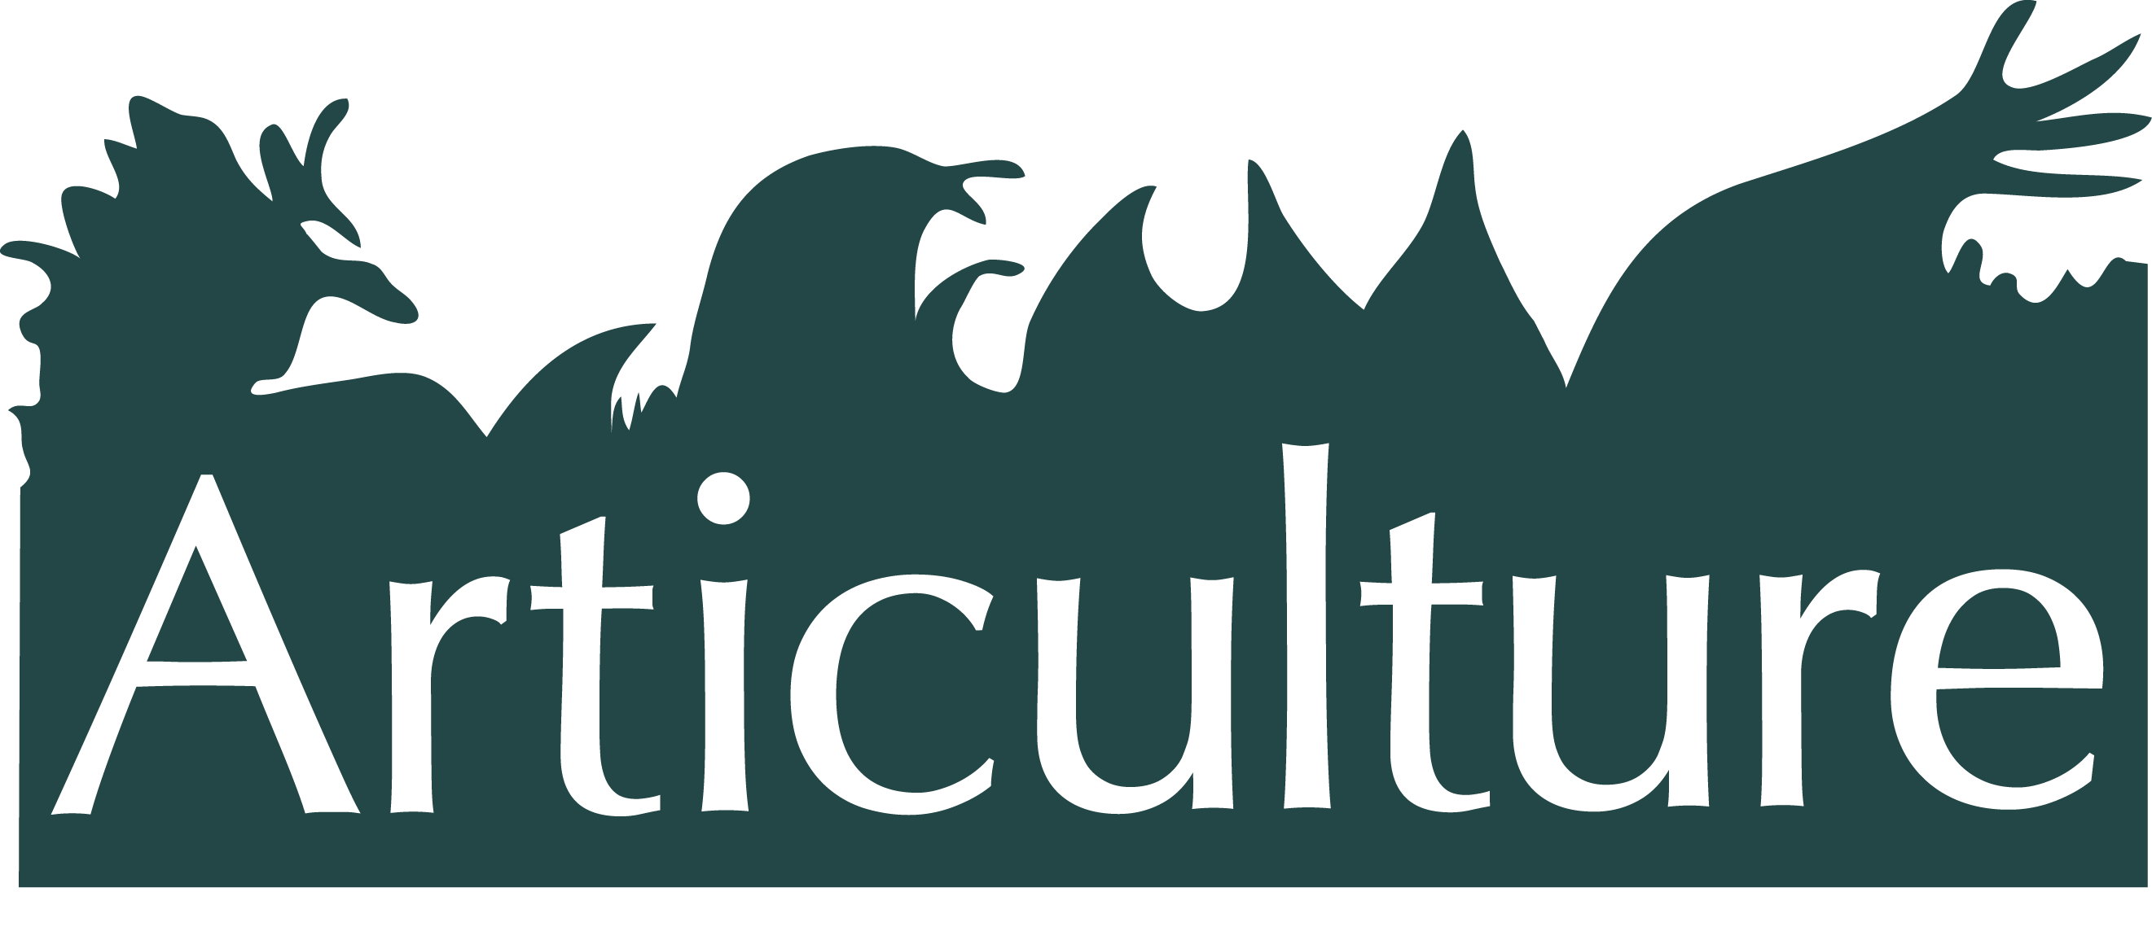

**The Great Outdoors Expedition 2014**

**Commissions Application Information**

Articulture has come together with the Wye Valley River Festival, the National Eisteddfod and Pontio Arts & Innovation Centre to offer three exciting commission opportunities to artists of any genre who want to create a small-scale, innovative and exciting work for outdoor spaces in Wales in 2014.

These opportunities are part of Articulture’s ‘Great Outdoors Expedition’ in 2014. Each commission will form part of one of three networking events produced by Articulture, which will take place at the Wye Valley River Festival, the National Eisteddfod and Pontio’s opening season.

This document includes information about the Expedition, Articulture and events partners, as well as eligibility, what you can expect from us and what we will expect from you as an applicant. You will find specific information about what you should include in your submission, so keep reading to the end!

**About The Great Outdoors Expedition**

Articulture Wales is an arts organisation that creates opportunities to bring together arts practitioners and promoters in Wales to support innovation, collaboration and production of unique outdoor performance.

Articulture’s Great Outdoors Expedition is a series of new ‘seed sowing’ opportunities mapped out across Wales that aims to spark the creation of innovative and high quality [outdoor arts](http://www.articulture-wales.co.uk/about/outdoor-arts/). These are open to all Wales based arts practitioners, funders, development officers, festivals and venues. The Expedition includes bursaries, networking events, mini encounters, and the chance to create new small-scale commissions.

The Great Outdoors Expedition takes forward the input of over a hundred practitioners who came to The Great Outdoors Conference in 2012 – Wales’ first national conference for outdoor performance. The Expedition is supported by the Arts Council of Wales.

**About the Great Outdoors Commissions**

Articulture has formed partnerships with the Wye Valley River Festival, the National Eisteddfod and Pontio to create and host three networking events in 2014.

Taking place in the Welsh landscape these experiential daylong events will bring together practitioners to create space to take part in the host event, share contacts and practice and explore new opportunities. Each event will form part of the host event’s high profile programme, responding to its ethos and audience.

Articulture, in collaboration with partners, will commission a new work for each of the three networking events. The aim of each of these commissions is to provide an opportunity for Wales based artists to work in partnership with a leading arts organization and to present innovative and quality ideas on a national platform.

Although not essential to the criteria for selection, it is hoped that these works will help forge partnerships that will help promote future work.

We are looking for ideas that are simple, participatory, striking and imaginative. Crucially they will be outdoors and will be responsive to the heart and ethos of the host event and would work for a highly diverse and bilingual audience. Your idea can encompass any genre(s), and can be time limited or ambient throughout the day. It will require minimal production and materials (where possible sustainable and recyclable).

**Who can apply?**

* An individual or group/collective based in Wales
* Arts projects encompassing any genre(s) that take place [outdoors](http://www.articulture-wales.co.uk/about/outdoor-arts/)

**If you are unsure as to the eligibility of your idea, please contact: info@articulture-wales.co.uk**

**Terms and Conditions**

On applying for this commission you agree:

* For the first showing of the work to be at the relevant chosen host event as part of Articulture’s The Great Outdoors Expedition.
* To be exclusively available to show the work during the chosen host event date
* To provide evidence that the work is deliverable within the parameters of the project and the budget available
* To be available to give interviews to the press and media and assist Articulture with our promotion of the project where reasonably required

**Briefs & Budgets**

This is a small scale-commissioning fund with individual briefs outlined below.

Articulture also welcomes new projects that have existing support, where our commission funds could be added to other sources of funding.

Awards will be based on the quality of the proposal, the strength of the idea and the ability to realise the idea in line with the relevant timescale and budget; taking into consideration the technical implications, installation and material costs. Articulture and the Event partners are more than happy to offer advice and feedback at all stages of the application process.

**Wye Valley River Festival**

* **About –** The Wye Valley River Festival is a brand new AONB (Area of Natural Beauty) initiative being developed by Desperate Men, in collaboration with a wide variety of artists and arts organisations at locations along the Wye River throughout May 2014. It will launch in Hereford and progress south along the river over the month, finishing in Chepstow. The first year of the festival is looking to give an overall ‘audit’ of the river. The Articulture commission will relate to the Monmouth event with a possible follow through at Llandogo.
* **Website –** Festival site in development. [www.desperatemen.com](http://www.desperatemen.com), [office@desperatemen.com](mailto:office@desperatemen.com)
* **Date** – 9th / 10th Monmouth and or possibly 11th Llandogo
* **Budget** - £1500
* **Venue** – Monmouth / Llandogo – riverside location to be agreed.
* **Specifics** - There will be a ‘trial’ of the river that evolves in the 16th court house in Monmouth Town Centre; people will give their testimonies / bear witness to the actions / state / uses of the river. The commission needs to link in with this and notions of testimony / witness / advocacy in relation to the River Wye. It can be a repeating event or could be something installed for the duration. Could move to other venues. Desire for something ‘ quirky / surprising / witty / extraordinary

**Further details of the narrative framework are available from Desperate Men.**

**The National Eisteddfod of Wales**

* **About -** The Eisteddfod is one of the world’s greatest cultural festivals, and brings together people from all ages and backgrounds to enjoy an eclectic mix of music, literature, dance, theatre, visual arts and much more. Held alternately in north and south Wales, the festival is also a two year long community project, bringing communities together, organising workshops for young people and providing opportunities for people to volunteer and learn new skills within their local area. The Eisteddfod exists to promote culture and the Welsh language, and includes hundreds of events and activities aimed at all ages and interests. The Eisteddfod has a long and varied history, which can be traced back as far as 1176.  The modern day Eisteddfod began in 1861 - see [here](http://www.eisteddfod.org.uk/english/about-us/our-history/celebrate-150/) for a wide range of articles and information relating to the Eisteddfod since then.
* **Website** - [www.eisteddfod.org.uk](http://www.eisteddfod.org.uk/cymraeg/2014/)
* **Date –** Between 1st to 9th August 2014
* **Budget** - £1500
* **Venue** - Millennium Costal Park, Llanelli
* **Specifics** – A commission that respond to the immediate physical environment and/or the history of the area.

**Pontio Arts & Innovation Centre – Opening Event**

* **About -** Bangor’s new arts and innovation centre ‘Pontio’ will open its doors in 2014. Home to a mid-scale theatre, a studio theatre, a cinema, administrative offices, design and innovation centre, Students Union, spacious lecture theatres, social learning spaces, bar, café and more – this new building will reinvigorate the city centre.
* **Website -** [www.pontio.co.uk](http://www.pontio.co.uk)
* **Date** - Mid October 2014
* **Budget** - £1500
* **Venue** – External performance space at the new Pontio Building /environs (currently under construction).
* **Specifics** - A commission that responds to Pontio’s existing Ha**Da**Synia**Da** project. It will also be sensitive to Jessica Lloyd Jones’ Public Art Commission - ‘The Light Meadow’ - a light installation in the landscape using LEDs.

The Ha**Da**Synia**Da** project to date has seenfour of Wales’ prominent bards. Dewi Pws, Eurig Salisbury, Tudur Dylan, Gerwyn Williams, Karen Owen and Ed Holden working with various Bangor and Anglesey schools to share their hopes and dreams for Pontio. Taking their inspiration from the children themselves the poets developed poems embodying their ‘idea seeds’. They now have around 800 individual seeds of ideas ready to be physically planted in the landscape of the new Pontio Centre during the summer.

**For Pontio images of the external performance space design and HaDaSyniaDa poems visit** [**here**](http://www.articulture-wales.co.uk/commissions/commissions-2014/)**.**

**Commissioning process**

**If you would like your project to be considered please email Articulture at** [**info@articulture-wales.co.uk**](mailto:info@articulture-wales.co.uk) **by 21st February 2014 with a Creative Proposal.**

This should be no more than 2 pages of text.

What you should include –

* The idea – what you would like to create/present
* An outline of the materials and processes you will employ in order to realise the idea
* An approximate budget for realising the idea, that does not exceed the set amount
* The significance/relevance of your chosen location to the idea you are submitting
* The relationship of the idea to the wider public; how will the public experience the work?
* A proposed timeline of how long you imagine the idea will take to be realised
* Your contact details including name, address, email, telephone and website (if applicable)

You are also welcome to enclose visuals, photos, sketches, or mock-ups of how you envisage the idea will look and examples of previous relevant work (if applicable).

**We are happy to help you with any enquiries. Please do not hesitate to get in touch with us – info@articulture-wales.co.uk, 07966 071073.**

**We expect to be able to confirm the three commissions in late Feb 2014.**

  