 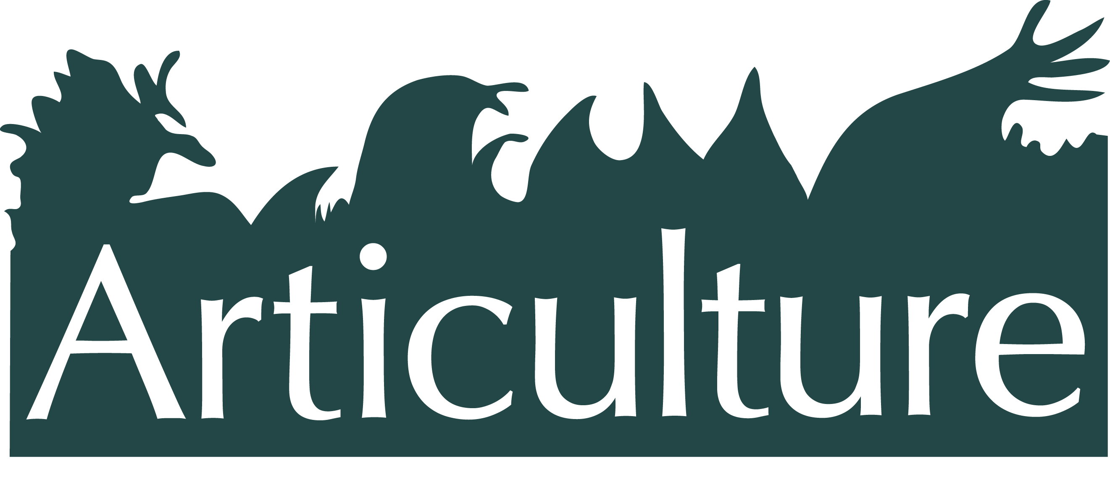

#### ****Professional Development Bursaries 2017****

Bursaries are now available for Wales based **artists** and **arts organisations** to fund their own 'go see' or skill share session, which will assist in the development of outdoor arts work.

For Articulture - 'Outdoor Arts' work -

* Can be permanent, but for this bursary supported work we are looking for mobile, participatory, performative, and time-limited shared art experience. We are not therefore able to support static artworks.
* Encompasses arts (of any form and combination) that are not confined to or dependent upon a designated building;
* Incorporates works that can exist or take place in a multitude of outdoor spaces, or site specific venues;

We are looking for bursary applications that enable quality opportunity for seeking out inspiration, and encouraging research, networking, skill sharing and partnership working, both in Wales and beyond. They are specifically available for those currently working in, or interested in developing outdoor art. Please note that we cannot support anyone who has already received a bursary from Articulture previously.

Through providing these bursaries it is hoped that a wider arena of sharing, connections and collaborations can be created for the development of outdoor arts in Wales. They are funded by the Arts Council of Wales. You can see some of the previous bursary recipients work [here](http://articulture-wales.co.uk/?s=Guest+artist+blog).

**Apply for an outdoor arts bursary**

Each bursary is up to £300 and can be used to cover travel, accommodation, fees and materials.

**What can I apply for?**

We are keen to keep the remit broad. A ‘go see’ or skill sharing could be, but is not limited to -

* An opportunity to visit and collaborate with another artist or arts organisation for such purposes as skill sharing, collaborative investigations, mentoring.
* A visit to a show, festival, conference with the purpose of networking and raising the profile of your work.

**It’s simple to apply - drop us an email at** [**julieann@articulture-wales.co.uk**](mailto:info@articulture-wales.co.uk), including –

* Your name
* Your address
* A very short description of your work (supplemented with a CV/website/images as you wish)
* A few sentences about what you hope to ‘give’ and what you hope to ‘gain’ with your bursary

**The deadline is rolling throughout the year, ending on 30 Sept 2017, or until all funds are allocated. Please check the Articulture website for updates.**