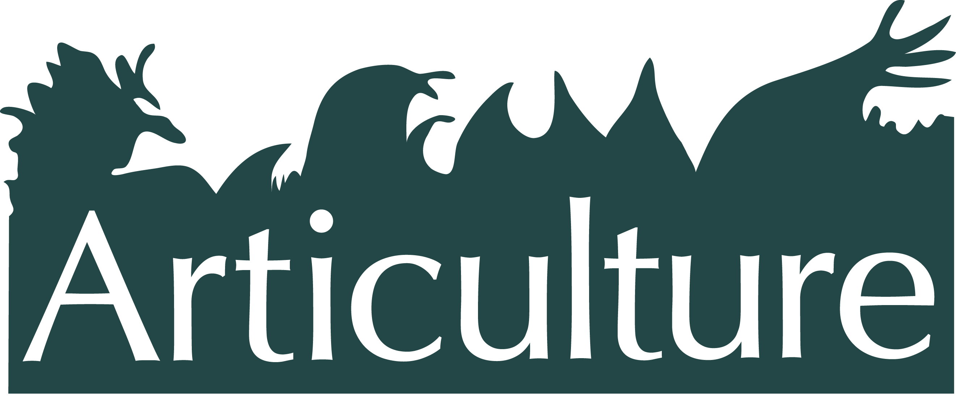

**The Great Outdoors Expedition 2014**

**- {Adventure No.2} -**

**The National Eisteddfod of Wales, Millennium Coastal Park, Llanelli**

**9am – 5pm, Wed 6th August**

Are you an artist, director, or producer interested in creating or presenting outdoor arts at The National Eisteddfod of Wales, the country’s leading cultural event, as well as other Welsh cultural events?

Join Articulture, the Eisteddfod team, and guest arts organisations, for a creative festival adventure with the opportunity to:

* **Meet the Eisteddfod Visual Arts Officer and Site Artistic Director**
* **Enjoy a unique tour of the festival**
* **Learn how others have done it, at the Eisteddfod and other cultural events,** including Arwel Gruffydd, Director, **Theatr Genedlaethol Cymru**, Bridie Doyle, Director, **Citrus Arts**, Geinor Styles, Director, **Theatr na nÓg**, and Gareth Lloyd Roberts, Director, **Aberystwyth Arts Centre.**
* **Network and brainstorm ideas** **for new work**
* **Talk informally to the Arts Council Wales about potential funding support,** and find out more about booking an advice session.
* **Enjoy festival performances**, including a brand new walk about commission by outdoor arts **Citrus Arts**, “Ceirw” (Deer), commissioned by Articulture in partnership with The National Eisteddfod of Wales.

**NOTE: Event program will be available through the medium of Welsh & English.**

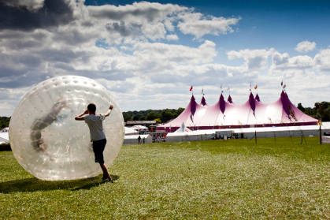

**Booking**

Tickets: £20. Students £15. Includes day entry to the festival (£18), tour, talks, lunch and refreshments. Book [here](http://www.seetickets.com/Event/creating-outdoor-arts/the-national-eisteddfod-of-wales/795043) or email info@articulture-wales.co.uk

**Getting there**

Festival Fields, Millennium Coastal Park, Llanelli, Carms, SA15 4DP. For full details visit [here.](http://www.eisteddfod.org.uk/english/2014/travell/)

**About the National Eisteddfod of Wales**

An eclectic mix of old and new, the traditional and the modern, the Eisteddfod is a celebration of Wales, its culture and its language.Wales’ leading cultural festival, it travels from place to place, alternating between north and south Wales giving communities across the country a chance to welcome up to 160,000 visitors over an eight day period. Watch an introductory film [here](http://www.eisteddfod.org.uk/english/2014/information-for-new-visitors/).

**About Articulture**

Articulture is a creative organisation that aims to bring together practitioners in Wales to support the creation of unique outdoor arts.

**For more info - 07966 071073 or visit** [**www.articulture-wales.co.uk**](http://www.articulture-wales.co.uk)



